**Problem 1. Use Appropriate Escape Sequence( \n, \t \b \ ..etc) for the problem below**

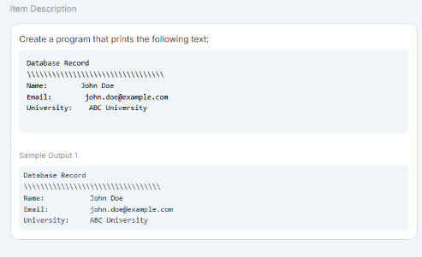

Source Code:

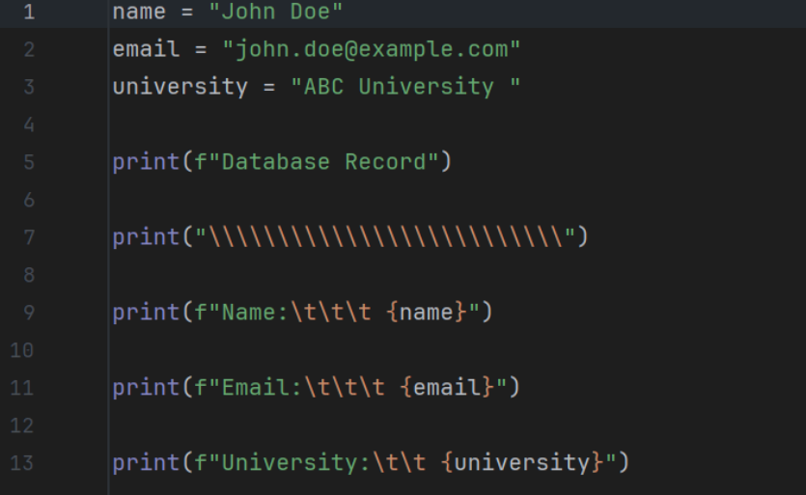

Output:

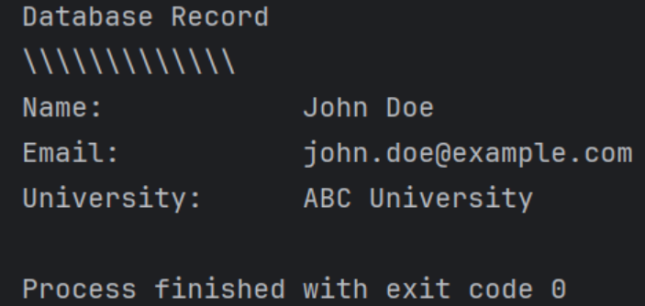

**Problem 2. Using Placeholders for Email Details: Use appropriate type specifiers %s, %d, %f etc… for this task**

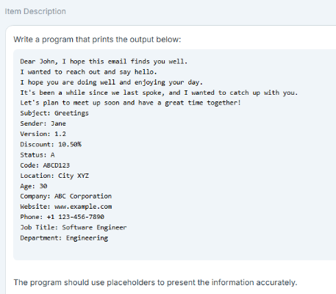

Source Code:

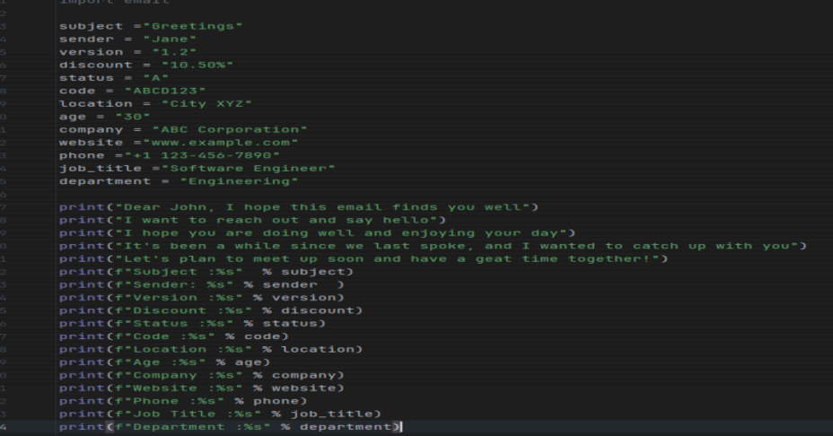

Output:

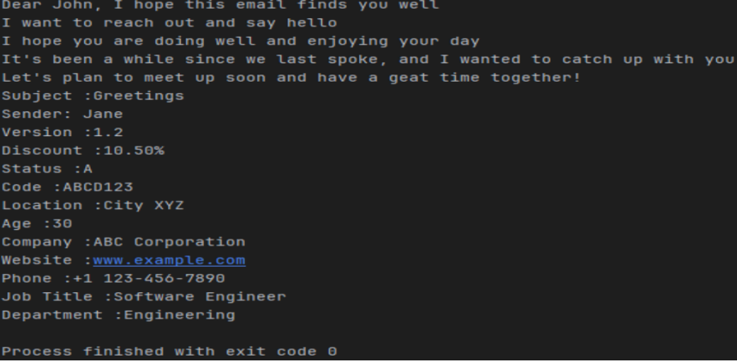

**Problem 3. Book Reservation; Accept User Input**

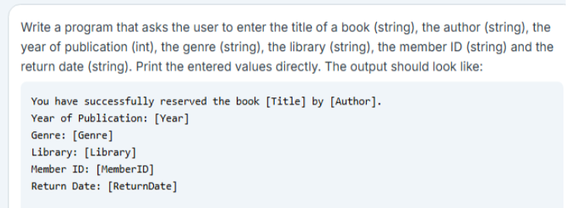

Source Code:

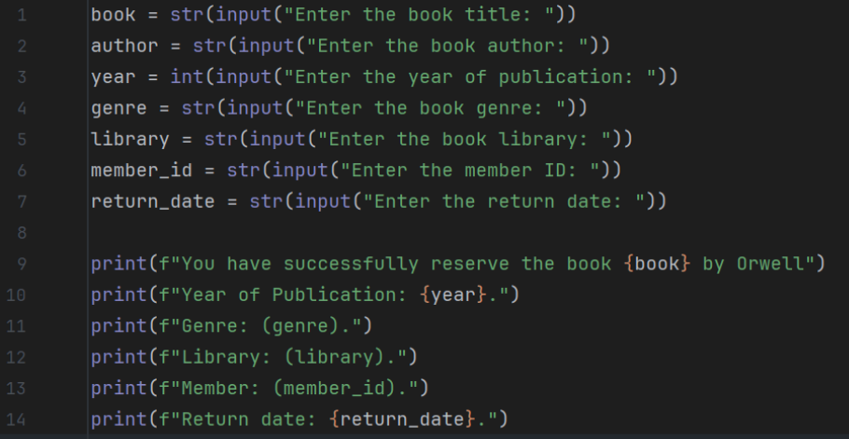

Output:

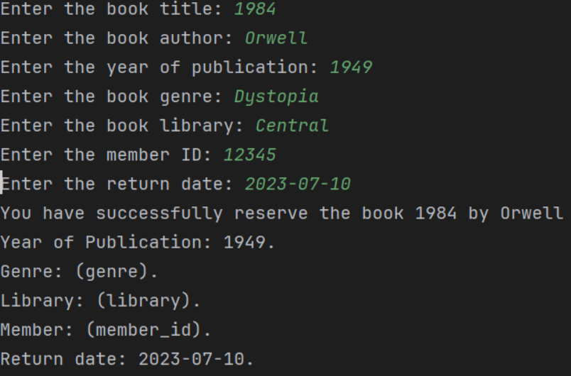

**Problem 4. Day Identifier**

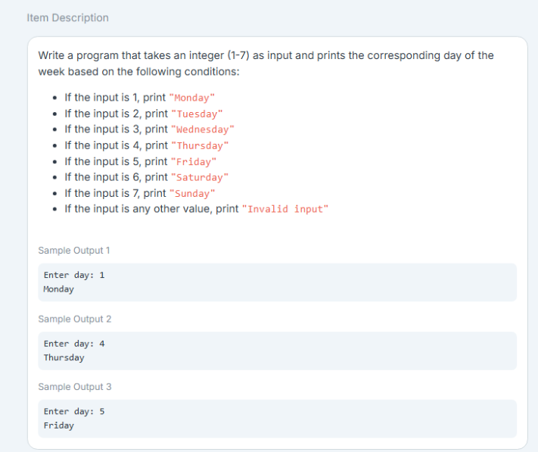

Source Code:

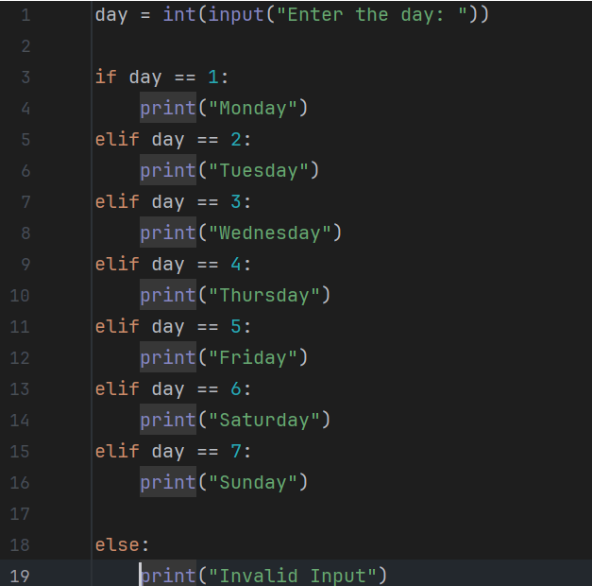

Output:

